Name: ______________________________________ Core: __________ Date: ______________

Quadrant 2 Word Bank:
Conjure Dilapidated Nimble Perceptive Optimistic Scavenged Unperturbed

1. _______________________

2. ______________________

3. ___________________________

4. ______________________

5. ___________________________

6. _____________________

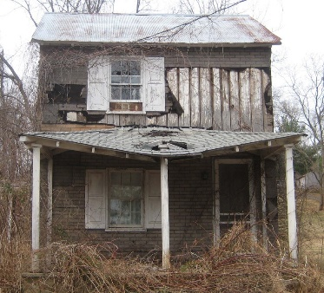 7. _____________________________

