Name: ______________________________________ Core: __________ Date: ______________

Alt. Quadrant 3 Word Bank:
Nuance Plagiarism Renown Tangent Abasement Billowing Cower

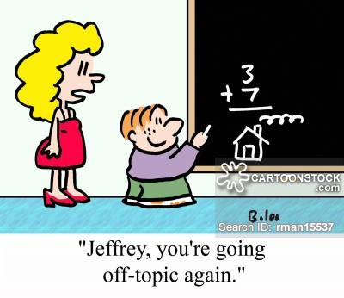
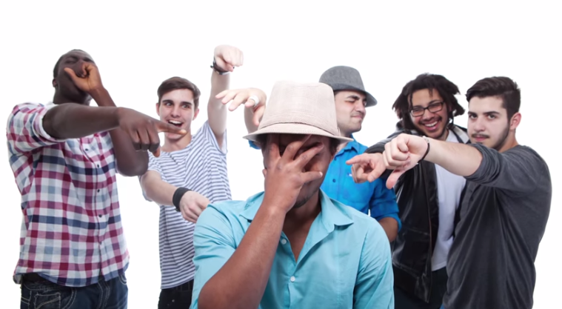

1. _______________________

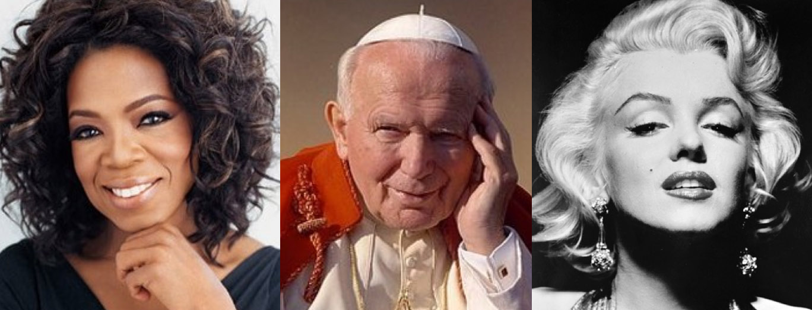

2. ______________________

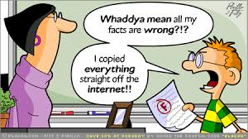

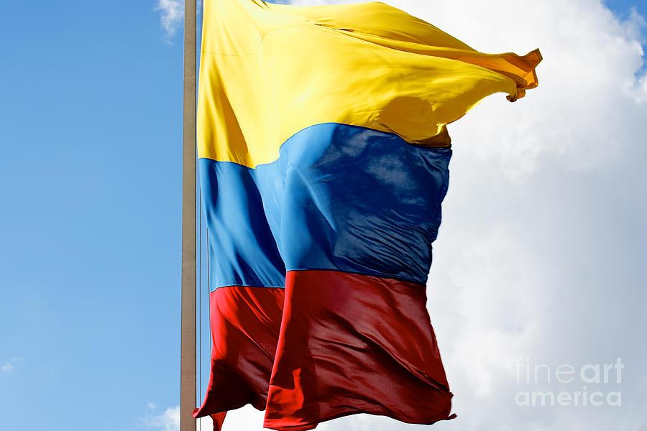

3. ___________________________

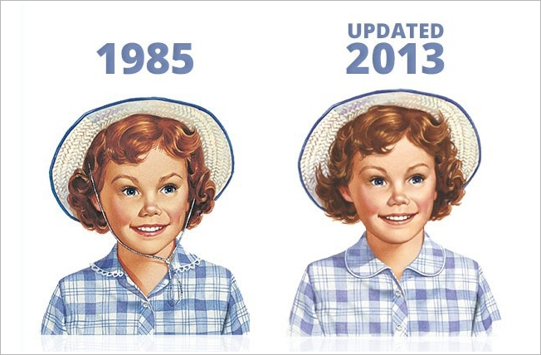

4. ______________________

5. ___________________________

6. _____________________

7. _____________________________

