Name: ______________________________________ Core: __________ Date: ______________

Alt. Quadrant 2 Word Bank:
Remuneration Talisman Abrasive Bilk Covert Engender Hanger

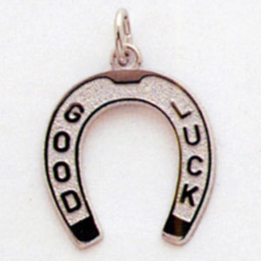
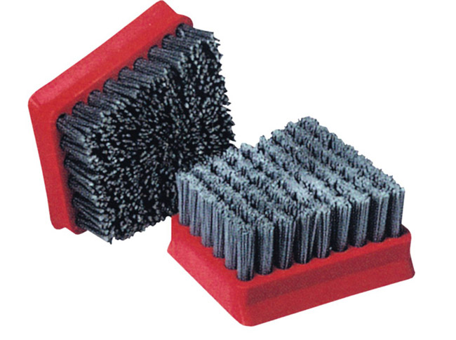

1. _______________________

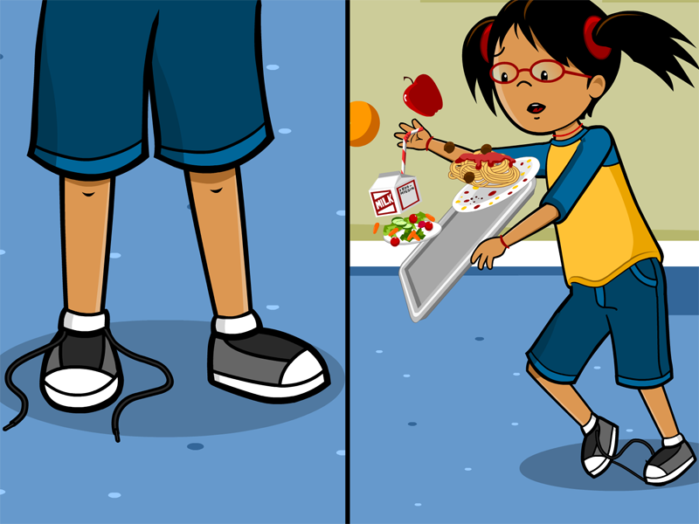

2. ______________________

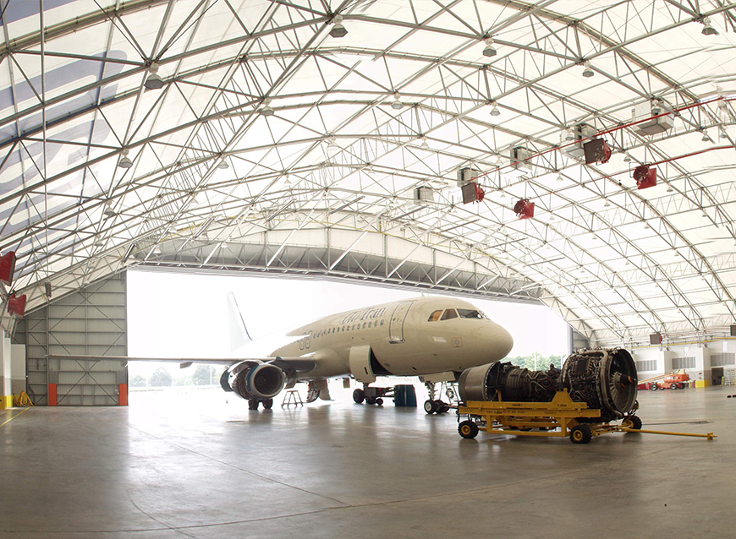

3. ___________________________
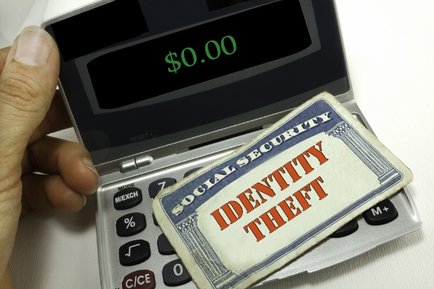

4. ______________________

5. ___________________________

6. _____________________

7. _____________________________

