Name: ______________________________________ Core: __________ Date: ______________

Quadrant 3 Word Bank:
Insignia Nuisance Stoic Tinge Prodigious Renegade Vigilant

1. ____________________

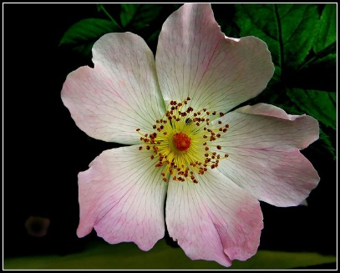 2. __________________________

3. _________________________________

4. ____________________________
5. _____________________________

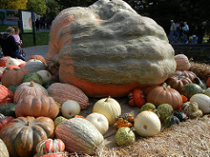 6. _________________________

7. __________________________

