Name _______________________________________ Core __________ Date _____________________

Code of Justinian vs. WA State Constitution

Scenario: Murder
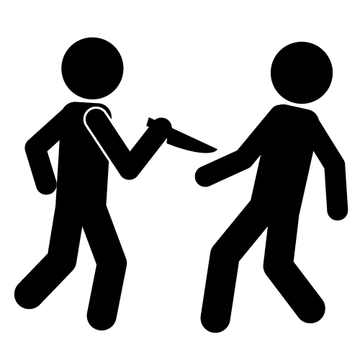

One day, Maximus was sawing the branches off of trees that hung over the sidewalk in front of his yard. Maximus forgot to put a sign on the sidewalk warning his neighbors of falling branches. His neighbor, Gaius, was out for a morning stroll when one of the branches struck and killed him.

- Is Maximus guilty of murder in the Byzantine Empire? Explain.

- Is he guilty of murder in Washington? Explain.

Name _______________________________________ Core __________ Date _____________________

Code of Justinian vs. WA State Constitution

Scenario: Murder

One day, Maximus was sawing the branches off of trees that hung over the sidewalk in front of his yard. Maximus forgot to put a sign on the sidewalk warning his neighbors of falling branches. His neighbor, Gaius, was out for a morning stroll when one of the branches struck and killed him.

- Is Maximus guilty of murder in the Byzantine Empire? Explain.

- Is he guilty of murder in Washington? Explain.

