Name: ______________________________________ Core: __________ Date: ______________

Alt. Quadrant 1 Word Bank:
Abhor Bigot Enfranchise Hamper Kindle Noxious Placid

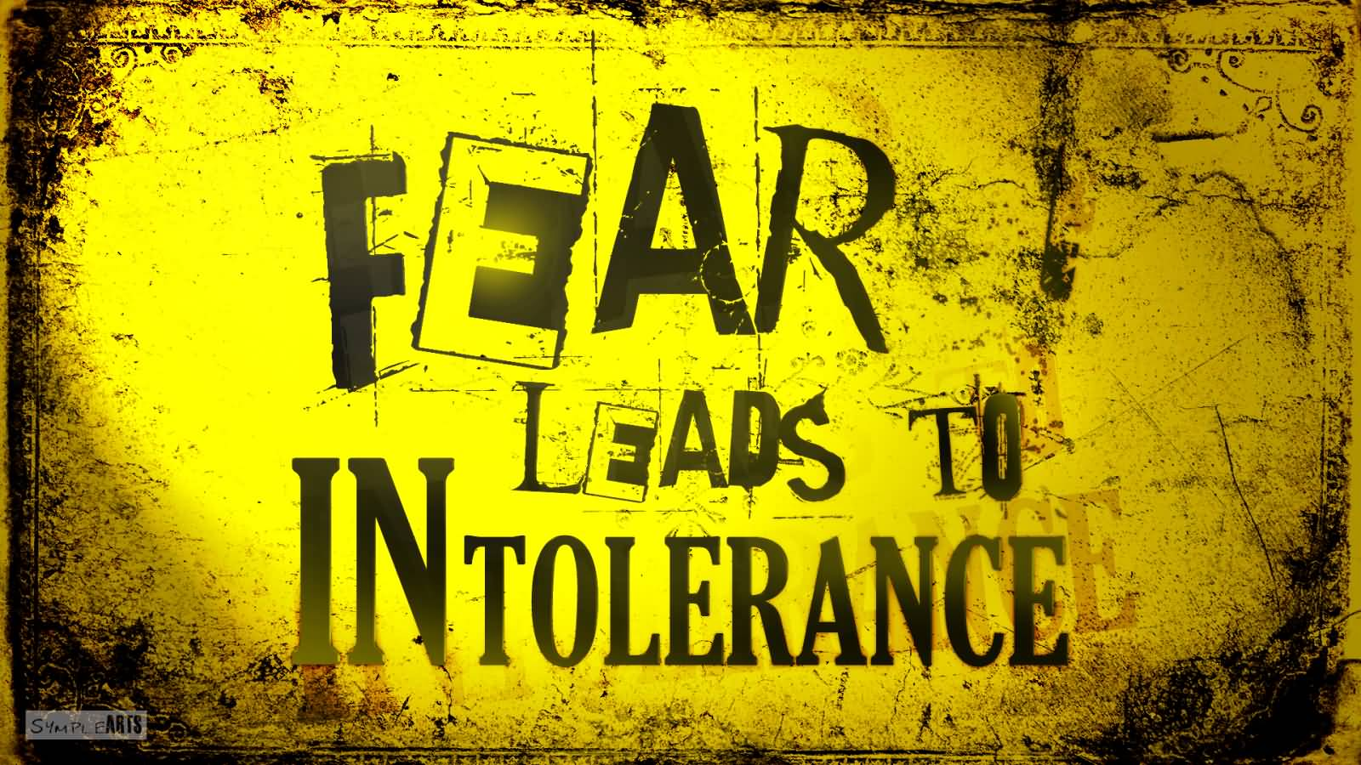

1. _______________________

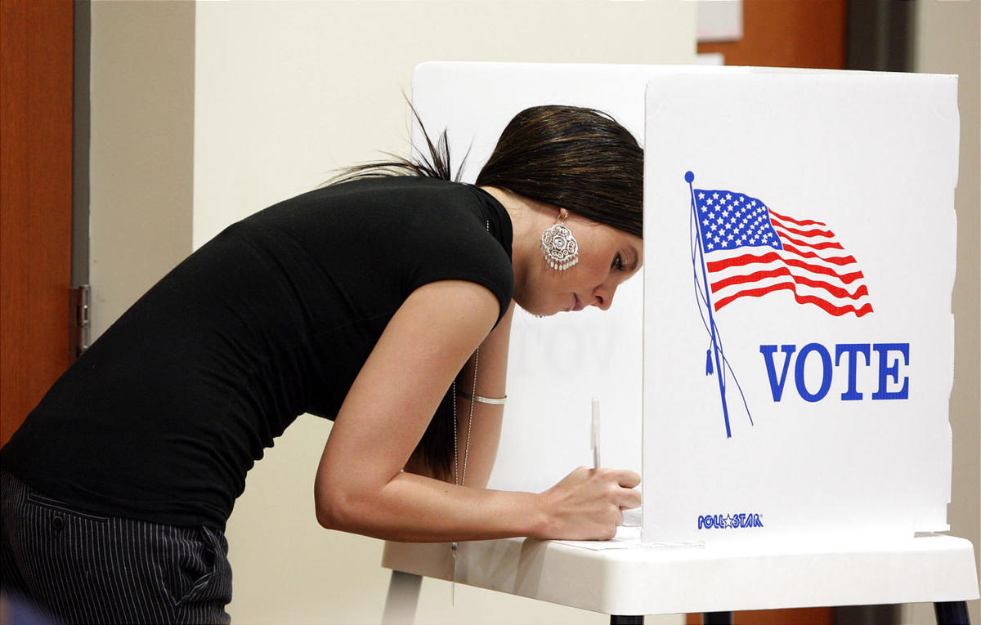

2. ______________________

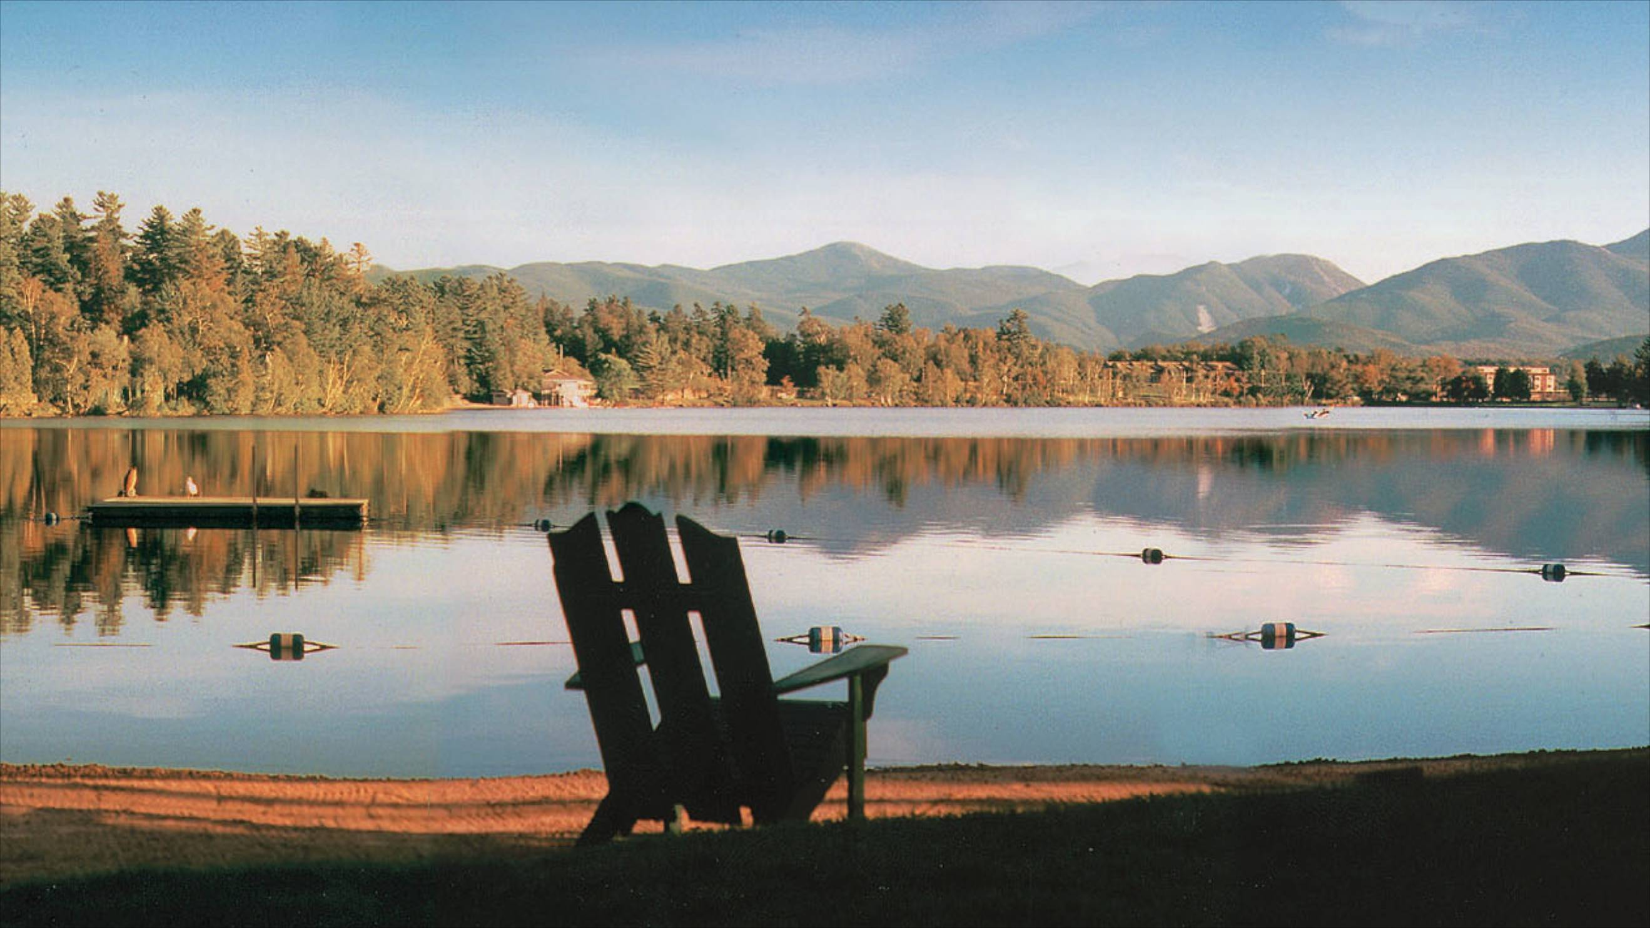
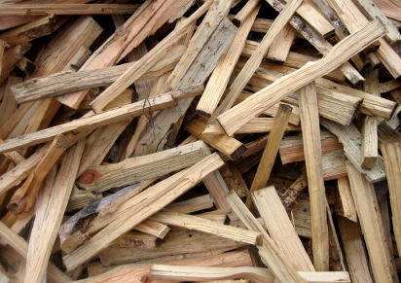

3. ___________________________

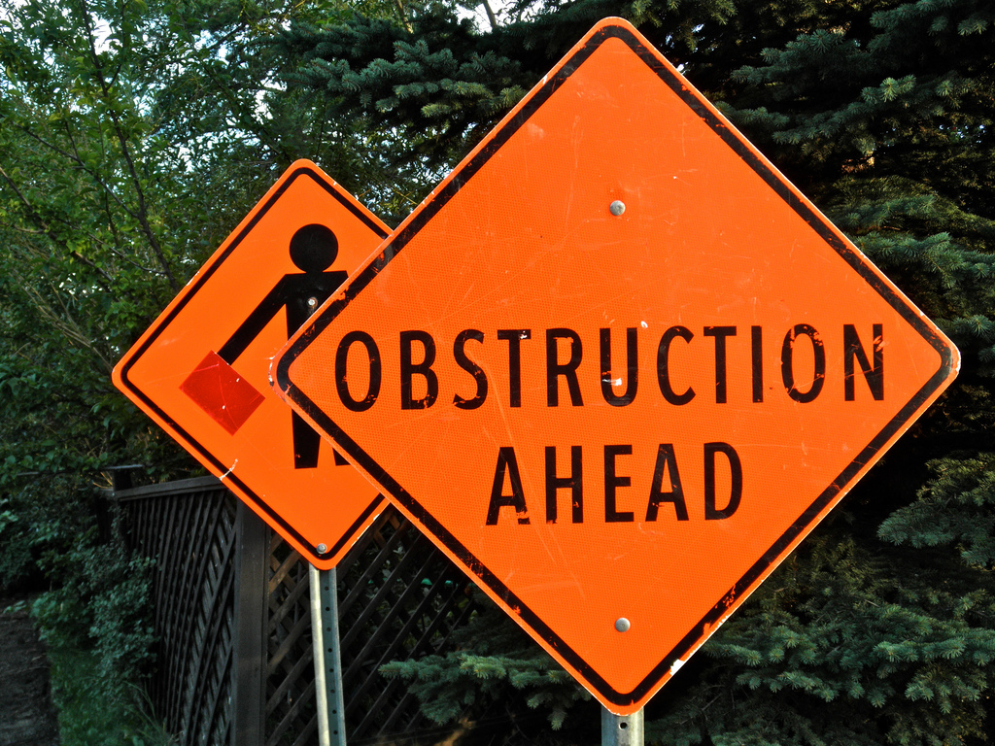

4. ______________________

5. ___________________________

6. _____________________

7. _____________________________

