Name: ______________________________________ Core: __________ Date: ______________

Quadrant 1 Word Bank:
Immaculate Mercenary Plague Prodigy Propaganda Rebuke Vain

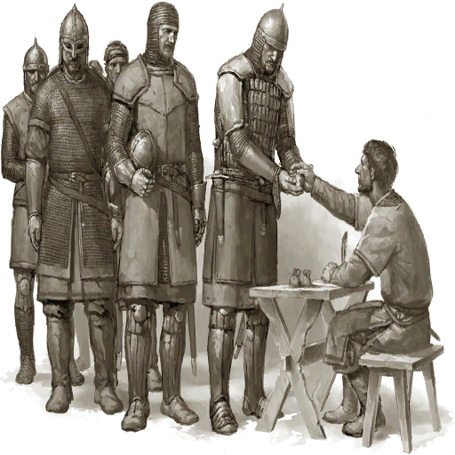

1. ________________________

2. ___________________

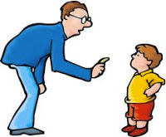 3. _______________________

4. ______________________________

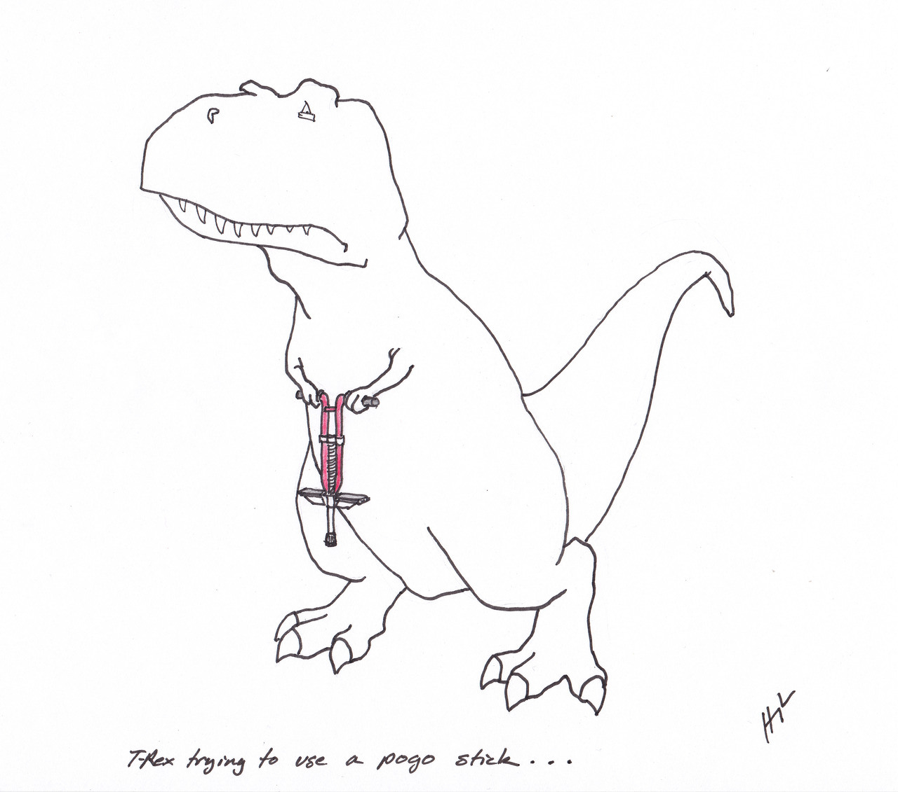 5. _________________________________
T-Rex trying to use a pogo stick

6. ________________________________________

7. _______________________________________

